|  |
| --- |
|  |
|  |
| **Supplier Quality Manual**  MAN9.1 |
| Version : 2.0  Release Date: April 2019 |
|  |
| **All Locations** |
| Approved by:  Director of Global Quality  Supply Chain Directors |

<< This page intentionally left blank >>

1. Introduction - 5 -

2. Doing Business with Komatsu Mining Corp. Operating Units - 5 -

2.1 Supplier Code of Conduct - 5 -

2.1.1 General Responsibility of Supplier and Sub-Tiers - 5 -

2.1.2 Commitment of Supplier - 6 -

2.2 Business Conduct - 7 -

2.3 Supplier Social Accountability - 7 -

2.3.1 Respect and Dignity - 7 -

2.3.2 Green Suppliers - 7 -

3. Communication / Information Transfer - 8 -

3.1 SAP (Business Management System) - 8 -

3.2 Supplier Quality Manual - 8 -

3.3 Supplier Network - 8 -

3.4 Request for Quote (RFQ) - 9 -

3.5 Technical Reviews - 10 -

3.6 Purchase Order - 10 -

3.7 KMC Drawings and Specifications - 10 -

3.8 Supplier Corrective Action Request - 10 -

3.9 KMC Quality / Part Approval Requirements - 10 -

3.10 Forms - 10 -

3.11 Supplier Management Review - 10 -

4. Quality System Requirements - 11 -

4.1 Quality Records - 11 -

4.2 Material Traceability - 11 -

4.3 Sub-tier Management - 11 -

4.4 Packaging and Labeling - 11 -

5. Supplier Selection - 12 -

5.1 Supplier Selection and Qualification Process - 12 -

5.1.1 Supplier Capability and Information Survey (MAN9.6-F1) - 12 -

5.2 Supplier Audits - 13 -

6. Part Qualification - 14 -

6.1 KMC Quality / First Article Requirements - 14 -

6.2 Part Submission Warrant - 14 -

6.3 Conformance of Regulatory - 15 -

7. Change Management - 16 -

7.1 Supplier Initiated Changes - 16 -

7.1.1 Deviation or Substitution to a Product - 16 -

7.1.2 Suggestion for Change - 16 -

7.2 KMC Initiated Changes - 17 -

7.2.1 KMC Engineering Change Communications Tools - 17 -

7.2.2 Other Changes - 17 -

7.3 Corrective Action - 17 -

8. Monitoring and Improvement - 18 -

8.1 Supplier Management Review - 18 -

8.2 Supplier Scorecard - 18 -

8.3 Vendor Inspection Database - 18 -

8.4 Premier Status - 18 -

8.5 Supplier Re-evaluation - 18 -

9. Terms and Definitions - 19 -

# Introduction

Komatsu Mining Corp. is a market leader in high-productivity mining solutions for underground and surface mining applications and is an operating unit of Komatsu Ltd. Our products and related services are used extensively for the mining of coal, copper, iron ore, oil sands, gold and other mineral resources. This operating unit shares a common supply chain process, although variations in application may arise due primarily to the kinds of equipment sold by each operating unit as well as their application (i.e., underground versus surface mining).

The purpose of this Komatsu Mining Corp. (KMC) Supplier Quality Manual (“Manual”) is to establish the minimum quality requirements for all suppliers of production materials, products and services to the operating units. Various documents and procedures referred to in this Manual may be found at <https://mining.komatsu/>.



For the remainder of this manual, Komatsu Mining Corp. will be refer to as KMC.

# Doing Business with Komatsu Mining Corp. Operating Units

## 2.1 Supplier Code of Conduct

KMC products and services are recognized throughout the world for their quality. Our commitment to integrity and social responsibility extends to its diverse and worldwide supply base. KMC understands that organizations supplying our company with goods and/or services vary greatly in size, length of existence, scope of product offerings and development of their management and manufacturing processes. However, we believe that there are some principles, values and practices that should be incorporated into all our routines.

It is important that our suppliers are fully committed to this cause, to ensure these objectives are respected and achieved.

KMC has created a Supplier Code of Conduct (”Code”) that reflects these values.

### 2.1.1 General Responsibility of Supplier and Sub-Tiers

This Code aims to clarify what KMC defines as ethical conduct in commercial relations with the companies that supply us with products and services. In the same way, we hope our suppliers will pass on these criteria to their suppliers and subcontractors, commonly referred to as sub-tier activities. Failure of any supplier or subcontractor to comply with this Code may result in suspension of business relations with KMC.

### 2.1.2 Commitment of Supplier

1. **Compliance with legislation, regulations and contracts**

Compliance with applicable legislation, regulations, codes and contracts is strengthened by our drive for sustainable development. This entails respect for human rights, workers’ rights, and rights pertaining to health, safety and the environment, but is not limited to these items.

1. **Management Commitment**

Suppliers must adopt or establish a management system designed to ensure compliance with this Code and applicable laws and regulations, identify and mitigate related operational risks, and facilitate continuous improvement.

1. **Respect and Dignity**

Suppliers will treat all employees with respect and dignity

1. **Confidentiality of Information**

Information of strategic value to Komatsu Mining Corp. must be treated as confidential.

* Confidential information is understood to mean the following:
  + Technical and commercial data regarding products
  + Business and commercial objectives, tactics and strategies
  + Annual budgets
  + Short- and long-term planning information
  + Purchase quantities and conditions
  + Results of research
  + Statistical, financial, accounting and operational data
  + Drawings / Prints
  + Standards and records
  + Supplier Scorecard(s)
* The foregoing information must not be disclosed to third parties;
* The foregoing information must not be used to further personal interests, for the private benefit of employees or third parties;

1. **Health and Safety at Work**

Suppliers agree to provide their employees with a safe and healthy workplace in compliance with all applicable laws and regulations, and implement management systems to demonstrate they meet these requirements.

1. **Documentation and Records**

Supplier shall have processes to identify, understand, and monitor their compliance with the obligations defined in this Code and all applicable laws and regulations.

## Business Conduct

Giving business gifts is commonplace and can represent merely a desire to build goodwill. However, many countries have very restrictive laws and regulations governing the offering to or receipt of gifts by those who may influence purchasing decisions. This includes quality representatives. Purchasing decisions must not be tainted by even the appearance of a conflict of interest or personal benefit.

KMC employees who have direct purchasing responsibilities, including employees in the purchasing department, engineering, supplier quality function, and other employees having a role in supplier selection, appraisal or approval are also restricted in gifts received, and may accept only (a) beverages, light snacks and business meals served during business meetings held at the facilities of suppliers, (b) business meals when in travel status, (c) promotional or advertising items having a truly nominal value, such as ball caps or pads of paper, and (d) any other business gift or thing of value if reported to, and approved in writing by an officer of KMC.

We ask that our suppliers to be cognizant of this policy, and refrain from putting KMC employees in situations that may lead to violation of this policy or applicable laws or regulations. Any KMC employee who solicits gifts from a supplier is in violation of this policy, and we ask that such violations be reported to the Global Supply Chain Directors.

## 2.3 Supplier Social Accountability

KMC’s commitment to integrity and social responsibility extends to its diverse and worldwide supply base. KMC understands that cultures and practices vary throughout the world. However, we believe that there are some principles, values and practices that should be incorporated into all our routines. It is important that all our suppliers are fully committed to this cause. This includes:

### 2.3.1 Respect and Dignity

Suppliers will treat all employees with respect and dignity and provide for the basic safety of them. KMC encourages suppliers to obtain ISO 18001 or equivalent certification, or other certification as designated by the KMC.

### 2.3.2 Green Suppliers

Suppliers will operate their facilities in a manner that minimizes impact on the environment, including measurable reductions in their use of energy, carbon emissions, as well as reduction in waste and reuse or recycling of supplies, materials, and waste. To this end, KMC encourages suppliers to obtain ISO 14001 or equivalent certification.

# Communication / Information Transfer

## 3.1 SAP (Business Management System)

KMC has committed to being a SAP based company. As such the mechanics of our supply chain system is designed around this system. The supplier, however, will not have direct access to the system.

## 3.2 Supplier Quality Manual

General supplier requirements are contained within this Manual. Supplier compliance with this Manual is required to conduct business with KMC. Performance of suppliers in meeting these requirements will be assessed on an ongoing basis, and will be a factor in supply strategy.

## 3.3 Supplier Network

The Komatsu Mining Corp. Supplier Network serves as a communication tool with KMC suppliers, to obtain information from and transfer information to KMC.

<https://mining.komatsu/> - No password required.

* Click Company
* Select Supplier Information

Supplier Network contains the following Supplier information:

* Forms
  + Supplier Capability and Information Survey (MAN9.6-F1)
  + Part Submission Warrant (MAN9.6-F5)
* Guidance documents
* Supplier Manual

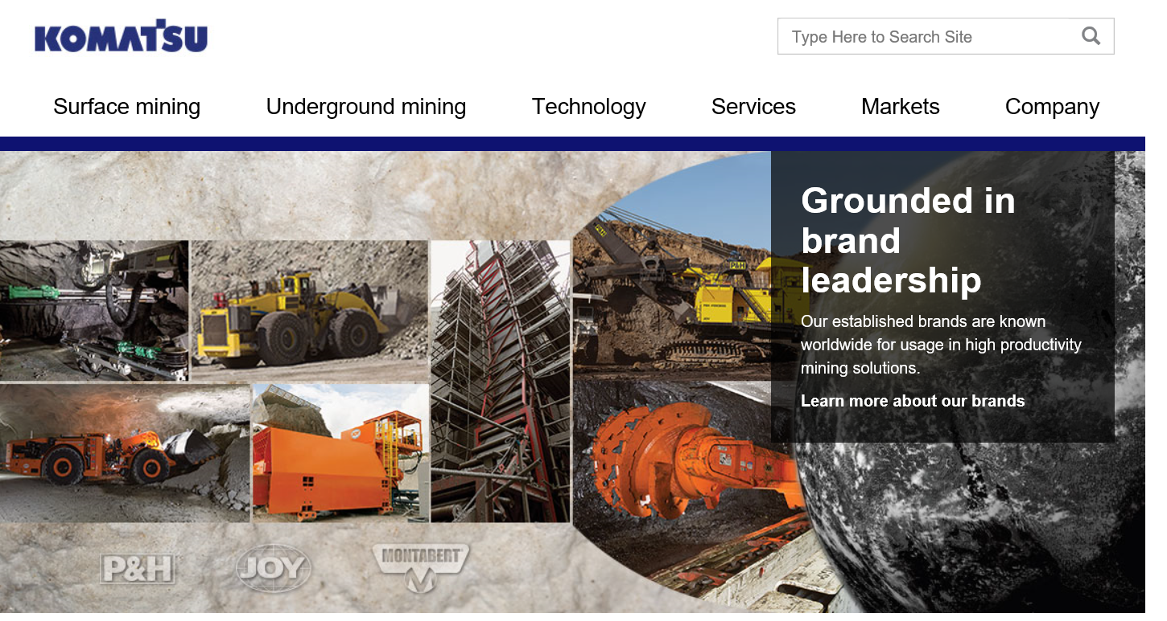

Figure 1: https://mining.komatsu/

## 3.4 Request for Quote (RFQ)

RFQ and attachment will typically contain all necessary documents for full quotation, such as:

* Reference Documents
* Quality Requirements
* Other Requirements
* Item
* Material / Part No.
* Description
* Quantity
* Estimated Annual Usage
* Other Costs
* Item, Quantity, Description, Lead Time, and Total Price

The supplier must contact KMC in the event the RFQ materials are illegible, unclear, or missing key information that is necessary for quotation. Later amendments or changes to supplier’s commercial proposals, due to any reason, will not be accepted.

RFQ is transmitted to Supplier as an electronic or paper document.

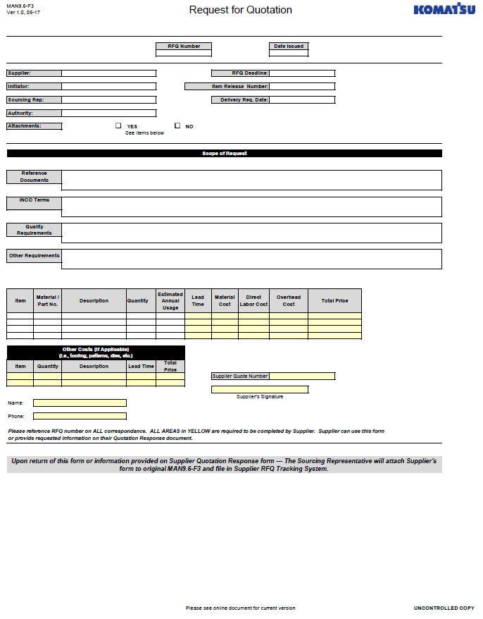

Figure 2: Request for Quotation

## 3.5 Technical Reviews

In many cases KMC will conduct technical reviews with suppliers to discuss specific requirements for a project. These reviews can be held in person or through electronic means (phone, web, and video).

## 3.6 Purchase Order

Product specific requirements may also be communicated on POs. Product drawings called out on PO’s may specify characteristics that affect the fit, form, and function of the product. Each PO should be followed by an acknowledgement from the supplier confirming for each part number, the price agreed, quantity and delivery date. Product configuration will be specified by the prints, in addition to the configuration specified by the part number. Acceptance of a PO constitutes acceptance of the standard Terms and Conditions on the PO, and shall not be modified by any terms and conditions set forth in supplier’s order acknowledgement unless specifically agreed to in writing by an authorized representative of KMC.

KMC’s Purchase Order will reference important requirements such as drawings, standards, specification, quality plans, and revision levels. Compliance with these requirements is mandatory. It is the responsibility of the supplier to question and resolve any conflicting or ambiguous requirements to order fulfillment.

Purchase Orders are transmitted to Supplier as electronic or paper document.

## 3.7 KMC Drawings and Specifications

KMC drawings will be sent with the RFQ and may also be attached to Purchase Orders. In some cases, suppliers will have access to KMC drawing databases.

Suppliers are expected to obtain international standards at their own expense. Whenever KMC supplies its own specifications, suppliers are expected to meet KMC specifications as well. These specifications should be clearly noted on the drawing, RFQ or attachments, or Purchase Orders.

The supplier should contact the KMC Sourcing Representative listed on the RFQ or PO for copies of these specifications.

## 3.8 Supplier Corrective Action Request

Should KMC have to issue a Corrective Action Request, it will be sent electronically or by mail to the supplier.

## 3.9 KMC Quality / Part Approval Requirements

First Article and other part qualification requirements are transmitted to the supplier via the RFQ or an attachment to the RFQ. A First Article Purchase Order will normally be issued that would contain requirements for the initial order.

## 3.10 Forms

Part Submission Warrant Form should be downloaded directly from the KMC Supplier Network. All other required documentation and forms should be submitted electronically to KMC.

## 3.11 Supplier Management Review

KMC will schedule Supplier Management Reviews with the Supplier by phone or e-mail.

# Quality System Requirements

All suppliers shall maintain an effective documented quality system. When specified, suppliers shall be certified to an industry recognized quality standard such as ISO9001 or ISO/TS16949.

Certification by an accredited third party registrar is highly recommended and in some instances, may be required (to meet a customer contractual obligation), and, in any case, will be a factor considered in the award or continuation of business with KMC. Any change in a third-party approval/certification status must be communicated by supplier to KMC if not regained by supplier within 90 days of change in approval/status.

## 4.1 Quality Records

All documentation relating to KMC components such as, but not limited to, inspection and test data, gauge calibration records, process control documents, final inspection records, corrective and preventive action records and any other record specified within the supplier’s quality system, must be maintained by the supplier and be available for review on request by KMC personnel.

Komatsu Mining Corp. Record Retention Policy requires the following retention period for the Quality Control and Inspection records of Suppliers:

* Supplier Internal Quality Data – 10 years
* Part Submission Warrant – 10 years

Refer to this policy for detailed retention requirements, which may be revised from time to time.

## 4.2 Material Traceability

The supplier must establish and maintain procedures for product identification during all stages of production, testing, final inspection and shipping in particular in respect to monitoring and measurement requirements.

When specified by the drawing or purchase order, the supplier will maintain and record the unique identification of the product, such as a serial number.

KMC may specify traceability requirements through the Request for Quote.

## 4.3 Sub-tier Management

KMC holds all suppliers responsible for the components manufactured in their plants and at sub-tier facility(ies), and reserves the right, but is not obligated to, visit sub-tier facility(ies).

KMC may specify requirements for additional sub-tier management in the Request for Quote or at other stages in the purchasing process.

## 4.4 Packaging and Labeling

All suppliers are responsible for properly packaging all material/goods/products shipped to KMC in order to protect it from damage in handling or deterioration from rust, corrosion or environmental factors. The supplier is obligated to assure the cleanliness of those components that have and maintain specific cleanliness requirements. These cleanliness requirements may be identified on the drawing, specification or called out in the RFQ and attachments.

# Supplier Selection



Figure 3: Supplier Selection

## 5.1 Supplier Selection and Qualification Process

KMC uses a broad-based process to select and approve suppliers. This process is called the KMC Supplier Selection and Qualification Process. During this process, KMC looks for suppliers that show strong quality processes, are financially viable, provide exceptional customer service, and are cost competitive. This process gathers information from many sources and may include an on-site audit.

To begin this process, the supplier will be required to complete the following:

* + [Register to become a Supplier](https://mining.komatsu/company/supplier-information/supplier-opportunities/register-to-become-a-supplier) with KMC
  + KMC Sourcing Representative will send to Supplier the following forms”
    - Supplier Capability and Information Survey (MAN9.6-F1)
    - Supplier Confidentiality Agreement (Legal Documents)

Some suppliers will be accepted with conditions that must be addressed before award of business. Upon approval, suppliers will be added to the List of Approved Suppliers.

### 5.1.1 Supplier Capability and Information Survey (MAN9.6-F1)

This form asks for information on a supplier’s facilities, capability and quality system. This form is found on the KMC Supplier Network along with instructions on completing and submitting it. A supplier may also receive it separately from a KMC Sourcing Representative.

## Supplier Audits

Supplier audits will be tailored to the requirements of the RFQ or Purchase Order and can vary in number and depth accordingly. Suppliers will be notified in advance of audits and the audit requirements. Where predesigned audit forms exist, they will be made available to the supplier prior to the audit. In other cases, members of the audit team will clearly express the intent and planned activities of the KMC audit team.

Suppliers are expected to cooperate with KMC audits. The results of any audits will be made available to the supplier and the supplier will have opportunity to respond to any findings.

In some cases, KMC may wish to have sub-tier suppliers audited. In these cases, KMC expects the first-tier supplier to initiate contract with the first-tier supplier(s) and encourage full participation.

**Komatsu Group of Companies Supplier Selection and Qualification Process:**

KMC considers the experience and expertise that has been developed with suppliers delivering to other Komatsu facilities across the globe.

If a potential supplier has been identified by Komatsu for cross organizational supply, an internal waiver for these suppliers can be raised by the regional KMC Supply Chain Representative (SCR). The waiver must be approved by the persons regionally responsible for Supply Chain and Supplier Quality Management.

This waiver will waive an on-site audit by KMC. The supplier will complete “Supplier Capability and Information Survey (MAN9.6-F1)” and submit to the SCR for KMC record keeping. This will be attached to the waiver.

Komatsu Group of Companies Supplier will be required to go through the First Article (FA) process to be added to the Approved vendors list. The waiver doesn’t waive the Supplier from the (FA) approval process as detailed in this manual. KMC needs to completely assess the supplier capability to supply a conforming product to all KMC requirements through the FA process.

# Part Qualification



Figure 4: Communications of Requirements Process Flow

## 6.1 KMC Quality / First Article Requirements

Quality requirements for a new product will be listed on each RFQ or attached documents and Purchase Order. For the initial shipment, the supplier will complete a Part Submission Warrant (“Warrant”). If the Warrant is not accepted by KMC, the supplier must make necessary corrections. If the Warrant is accepted, it will be returned signed and the supplier will be authorized to ship the parts covered by the Warrant. A new Warrant will not be required for future shipments, unless requested by KMC.

Future shipments will still have to follow quality requirements as listed on the relevant purchase orders. These may change after the Warrant is submitted, so the supplier is advised to validate quality requirements with each new purchase order received.

## 6.2 Part Submission Warrant

The Part Submission Warrant is used to document all part qualification requirements relevant to a specific supplier and part. The form for the Part Submission Warrant can be found on the KMC Supplier Network. Instructions for filling the form out are embedded in the form and can be accessed by scrolling over a field.

The supplier will submit the Warrant whenever instructed to do so by KMC. Normally KMC will ask for a Warrant for new first articles, and for existing parts where there has been major manufacturing change such as factory location, process or tooling, a major sub-tier supplier change or a design change.

[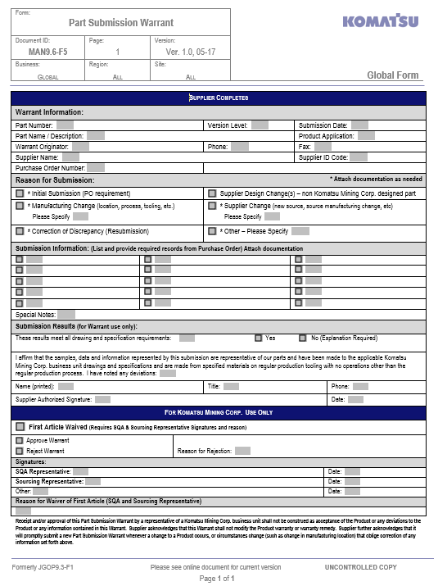](http://jgn.joyglobal.com/workspaces/res/operations/quality_ph/Documentation%20Demo/MAN9.6-F5_Part%20Submission%20Warrant.docx)

Figure 5: Part Submission Warrant

Reasons for submission of Part Submission Warrant include:

* Initial Submission (First Article PO requirement)
* Manufacturing Change
* Correction of Discrepancy
* Supplier Design Change(s) – non JGI designed part
* Supplier Change
* Other

## 6.3 Conformance of Regulatory

There are certain regulatory requirements that are applicable for components used in explosive atmospheres (such as underground mines) or to components used in certain countries. When this is the case, the supplier will be notified specifically of the requirement and of actions to be taken.

# Change Management

## 7.1 Supplier Initiated Changes

In certain instances, a supplier may identify situations where they feel it is advantageous to ship a product that does not meet the published specification. These instances can be through deliberate actions such as value engineering whereby a substitution or change request to a product to reduce cost or improve manufacturability, or they can be through inadvertent actions where non-conformances were incurred which do not, in the opinion of the supplier, affect form, fit and function.

Suppliers will never ship parts that do not fully meet KMC requirements and specifications without specific prior written approval. Suppliers must therefore, notify KMC of such situations and obtain written approval of authorized representative of KMC before any shipment occurs.

KMC reserves the right to require a new Part Submission Warrant.

### 7.1.1 Deviation or Substitution to a Product

Prior to shipping any non-conforming product or product produced by a process or tooling not covered by the relevant Part Submission Warrant, suppliers must submit a deviation request to the KMC Sourcing Representative and obtain approval. Deviations of material are handled differently administratively than other changes.

#### Material Substitution Request

Requests for raw material substitution or deviations from material listed on drawings or on relevant specifications will use the Material Substitution Request. This request must be completed on the link found on the KMC Supplier Network. Instructions are on the same site.

The response from KMC will be emailed directly to the supplier.

Globally certified product cannot be submitted for a deviation.

#### Process Deviation Request

For any deviation not covered by the Material Substitution Request, the supplier will use the Process Deviation Request. This request must be completed on the link found on the KMC Supplier Network. Instructions are on the same site.

The response from KMC will be emailed directly to the supplier.

Globally certified product cannot be submitted for a deviation.

### 7.1.2 Suggestion for Change

KMC expects suppliers to constantly strive to improve quality and reduce process variation through system improvements as well as undertake other actions to reduce cost. In these cases, where the changes have not taken place, the supplier should contact the KMC Sourcing Representative directly.

## 7.2 KMC Initiated Changes

From time to time KMC may request a change to a product, process or sub-tier supplier. These changes may be for quality or cost improvement, or for other reasons. KMC will formally notify the supplier of any such changes.

### 7.2.1 KMC Engineering Change Communications Tools

When an engineering driven change is required by KMC, the supplier will be notified separately along with any implementation details. KMC may require a new Part Submission Warrant in these cases.

### 7.2.2 Other Changes

When an engineering driven change is required by KMC, the supplier will be notified separately along with any implementation details. KMC may require a new Part Submission Warrant in these cases.

## 7.3 Corrective Action

A Supplier Corrective Action Request (SCAR) may be issued when products or services do not meet the purchase order requirements. The supplier will be advised of the discrepancy and requested to take immediate action to contain any other product from reaching KMC and to implement corrective action. The supplier will investigate and report the root cause of the discrepancy and the actions taken to prevent recurrence with affectivity dates. If a SCAR is not answered by the date due it will adversely affect the supplier’s performance rating.

# Monitoring and Improvement

Feedback on supplier performance is a critical component for any positive supplier-customer relationship. Performance metrics and regular discussion provide the basis for understanding and continuous improvement efforts.

Improvement targets may be established and reviewed on a schedule set by KMC. When requested, suppliers are expected to provide formal status updates on actions taken to address poor performance. KMC reserves the right to formally assess supplier performance and to take actions to protect KMC and our customers.

Suppliers with outstanding performance may be selected by KMC to receive the benefits of Premier Supplier.

## 8.1 Supplier Management Review

KMC may schedule formal discussions with the supplier. These discussions will cover supplier performance metrics (e.g., cost, delivery, quality, risk), and supplier concerns. Suppliers are encouraged to discuss any communications issues they have with KMC at these reviews.

## 8.2 Supplier Scorecard

KMC generates formal supplier scorecards on selected suppliers. These scorecards are generated by the KMC SAP system and cover on-time delivery performance, quality performance (lot rejections) and deviations.

If a supplier is selected to be monitored by this system, they will receive a copy of the scorecard electronically each month.

## 8.3 Vendor Inspection Database

Certain components require more frequent inspection than others. In these cases, suppliers will be required to conduct inspections at their own sites and enter them into the Vendor Inspection Database. If you are chosen for this program you will be provided the necessary details.

## 8.4 Premier Status

Some suppliers are designated as having Premier Status based on certain performance criteria. Suppliers in this category receive recognition from the company, are included in KMC OPEX events, among other benefits.

## 8.5 Supplier Re-evaluation

Periodically, suppliers are audited by KMC to evaluate the following, but not limited to:

* + Quality history
  + On-time delivery
  + Quality management system
  + Corrective Action Requests

Prior to re-evaluation, supplier will be notified by e-mail or phone and provided a copy of the previous audit (MAN9.6-F1) to verify that information is current and valid.

Suppliers of globally certified product will be re-evaluated annually.

# Terms and Definitions

| Term | Definition |
| --- | --- |
| AIAG | Automotive Industry Action Group. The AIAG was founded in 1982 by Ford, General Motors and DaimlerChrysler. It is the originator and sole source of the QS9000 series of quality standards, and provides training and information on the QS quality requirements. |
| Capability | Maximum amount of variation inherent in a manufacturing process.  "Improving process capability"  Involves taking steps to limit the amount of variation to defined acceptable limits and thus bring the process into control. |
| Capability Index | A comparison of the available tolerance to the portion of the tolerance consumed by a process in a state of statistical control. |
| CAPA | Corrective Action Preventive Action request. A formal request by KMC to take action to eliminate the cause(s) of an existing nonconformity or other undesirable situation in order to prevent recurrence. |
| Compliance Assessment | An evaluation by a first, second, or third party that provides assurance that a product or process conforms to the stated standards or documents. |
| Control Plan | A Control Plan is a written description of the system for controlling parts and processes. The Control Plan describes the actions that are required at each phase of the process, from receiving to shipping, to assure that all process outputs remain in a state of control. The Control Plan reflects a strategy that is responsive to changing process conditions, and is maintained and used throughout the product life cycle. |
| Cpk | This is the process capability index that accounts for process centering and is defined as the minimum of CPU or CPL, where: The estimate of sigma (Σ) is based on the inherent, or within subgroup variation. This is the variation due to common causes only. |
| Critical Characteristics | Characteristic for which quality planning actions must be included in the control plan. |
| Declaration of Conformity | A signed statement issued for a product or process declaring that said product or process conforms to the standards or documents listed in the declaration. |
| Equipment | For purposes of this manual, “Equipment” is understood to include both tooling and machines. |
| First Article | Inspection for each unique manufacturing part number prior to or concurrent with the first part or group of parts created under a controlled and establish process. |
| FMEA | Failure Mode and Effects Analysis. A preventive analytical technique to methodically study the cause and effects of potential failures in a product or a process. The product or process is examined for all the ways in which a failure can occur. For each potential failure, an assessment is made of its effect on the system and its seriousness, and a review is made of the action being taken (or planned) to minimize the probability of failure or to minimize the effects of the failure. |
| Gage R&R | Gage Repeatability and Reproducibility. The evaluation of a gauging instrument's accuracy by determining whether the measurements taken with it are repeatable and reproducible. |
| Globally Certified Product | Any item required by regulation to be assessed against a specified set of standards and identified with a unique numbering scheme. |
| Integrated Product Development | The practice of utilizing teams to develop products in order to ensure that all elements of the product life cycle are addressed. |
| ISO | International Organization for Standardization |
| ISO 9000 | A set of international standards on quality management and quality assurance developed by the International Organization for Standardization (ISO) to help companies effectively document the quality system elements to be implemented to maintain an efficient quality system. The standards, initially published in 1987, are not specific to any particular industry, product or service. The standards underwent major revision in 2015 and now include ISO 9000:2015 (definitions), ISO 9001:2015 (requirements) and ISO 9004:2009 (continuous improvement). |
| ISO/TS 16949: 2000 | An international quality management standard for the automotive industry. Its official title is ‘Quality Management Systems - Particular requirements for the application of ISO 9001:2000 for automotive production and relevant service part organizations’. |
| Nonconforming Product | A product’s or service’s non-fulfillment of an intended requirement or reasonable expectation for use, including safety considerations. |
| OPEX | Operational Excellence. Operational Excellence is a philosophy of leadership, teamwork and problem solving resulting in continuous improvement throughout the organization by focusing on the needs of the customer, empowering employees, and optimizing existing activities in the process. |
| OTD | On time delivery. |
| Ppk | This is the process performance index that accounts for process centering and is defined as the minimum of: The estimate of sigma is based on the total variation, using all of the individual sample data from either a control chart or a process study. This is the variation is due to both common and special causes. Ppk should only be used to compare to or with Cpk and to measure and prioritize improvement over time. |
| PPM | Parts Per Million. A measurement of the defect rate in a product, calculated as:  PPM = (Total number of defective parts) x 1,000,000 / (Total number of parts used). |
| Premier Supplier | Premier Supplier meets the following criteria:  • The supplier is not blocked in SAP.  • The supplier is an existing supplier with a Vendor Master established in SAP.  • The supplier’s cumulative quality score is greater than 99% for the previous fiscal year.  • The supplier’s cumulative on-time delivery score is greater than 95% for the previous fiscal year.  • The supplier meets or exceeds supplier’s material productivity goal for the previous fiscal year.  • The annual spend is greater than $500,000 for the previous fiscal year or by recommendation of JGI Strategic Sourcing Council (SSC). |
| Process Capability | The range over which the natural variation of a process occurs as determined by the system of common causes. Process capability has three important components: the design specification, the centering of the natural variation, and the range or spread of the variation. The importance of process capability is in assessing the relationship between the natural variation of a process and the design specifications. This relationship is often quantified by measures known as process capability indices. The most common of these are CPK and PPK. |
| Part Qualification Process | Structured activities leading up to acceptance of a product. |
| Repeatability | Variation in a measurement system caused by the combined sources of measurement variation of gage or test equipment when used by one operator or under one set of environmental conditions. |
| Reproducibility | Variation in measurement averages when more than one operator or set of environmental conditions are imposed on the gage or piece of test equipment. |
| Sourcing Representative | KMC term that refers to person that works with Supplier. Terms related are Buyer, Sourcing Agent, Purchaser, etc. |
| Sub-Tier Suppliers | A successive supplier who provides a product or service to a direct supplier who ultimately provides that product or service to the customer. |
| Subcontractor | A person, company, etc., that enters a subcontract, esp. a firm that undertakes to complete part of another’s contract. |
| Supplier | "An individual or an organization who supplies goods or services to the company. This is also sometimes referred to as a “vendor.” In some settings—where a company provides goods through a distribution network—network members may be referred to as suppliers, even though they are the immediate customers of the company." |
| Supplier Management Review | This meeting is a review of all requirements related to agreement between Joy Global and Supplier for goods or services. |
| Technical Review | Discussion or meeting between Joy Global personnel (Sourcing Rep, SQA Rep, Engineering, etc.) and Supplier to discuss requirements of RFQ and to ensure that all issues and concerns are addressed prior to issuing a RFQ or Purchase Order. |
| Traceability | The capability to trace goods along the distribution chain on a batch number or series number basis. |